UNIT 6
Lesson 5 – NOT SO ORDINARY HOBBIES

1 What do you do in your free time?
Have you got a hobby? What is it? Talk to your classmate.
Ask him / her about his / her hobbies?
Što radiš u slobodno vrijeme? Imaš li hobi? Što je tvoj hobi?
Povedi razgovor sa svojim prijateljem iz razreda.
Pitaj ga / nju on njegovim / njenim hobijima.

2 a) Look at the pictures.
Who do you see? What is he doing?
Pogledaj slike. Koga vidiš na slikama? Što se dešava na slikama?

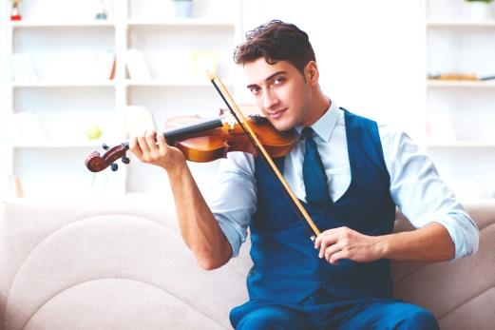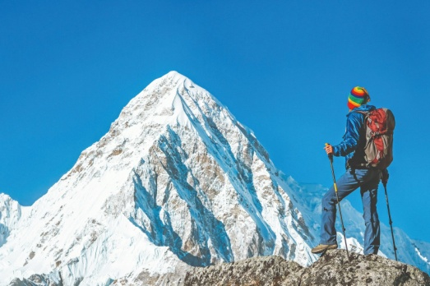

b) Circle the correct answer / picture. Zaokruži točan odgovor / sliku.
1 I can see a man / woman . 
Vidim muškarca / ženu.
2 He is playing the violin / the guitar.
On svira violinu / gitaru.


3 He is climbing a mountain / swimming in the sea.
On se penje na planinu / pliva u moru.

c) Listen to your teacher read the text.
Find out more about the man in the pictures.
Poslušaj svog učitelja kako čita tekst. Saznaj nešto više o čovjeku sa slika.

Clive the climber
Clive is a music teacher. 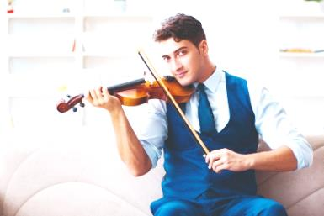
Clive je učitelj glazbenog.
Every day he goes to school. Every afternoon
On ide u školu svaki dan. Svako popodne
he practises the violin.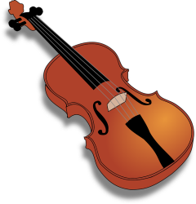 It’s different today.
vježba sviranje violine. Danas je nešto drugačije.


Clive is on holiday. It’s summer. . But it’s freezing cold
Clive je na praznicima. Ljeto je. Ali je jako hladno.

He is climbing Mount Everest. 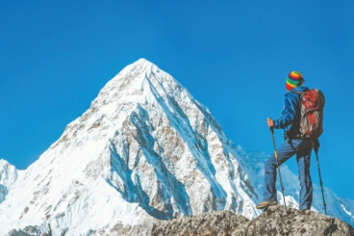.
On se penje na Mount Everest.

d) Listen to your teacher read the text again. Match the questions to their answers.
Poslušaj još jednom svog učitelja kako čita tekst. Spoji odgovore s pitanjima.
A Clive plays the violin every day.
Clive svira violinu svaki dan.

B Clive is climbing Mount Everest
today.
Clive se danas penje na Mount Everest.
1 What does Clive do every day?
Što Clive radi svaki dan?

2 What is Clive doing today?
Što Clive radi upravo sada?

e) Fill in the gaps with the correct expressions in orange.
Dopuni rečenicu izrazima u narančastom.

IS CLIMIBNG (penje se) PLAYS (svira)

1 Every day Clive _________________ his violin,
Svakog dana Clive_____________________ svoju violinu,

but today he _________________ Mount Everest.
ali danas se ______________________ na Mount Everest.

5 These are the pictures of Tia and her family.
The first picture shows what family members usually do at the weekend. The second picture shows what they are doing now. Ovo su slike Tije i njezine obitelji. Prva slika pokazuje što oni obično rade za vikend. Druga slika pokazuje ono što rade sada / ovog vikenda.

Listen to your teacher read the questions and the answers.
Point to the picture your teacher is talking about.
Poslušaj svog učitelja kako čita pitanja i odgovore.
Prstom pokaži na sliku o kojoj govori.

1 FREDERICK

USUALLY AT THE WEEKENDS NOW
( vikendom) (sada)
tell stories to his grandchildren write a book of stories
(priča priče unucima) for kids
(piše priče za djecu)
A What does Frederick usually do at the weekend?
Što Frederick obično radi za vikend?
Frederick usually tells stories to his grandchildren
at the weekend.
Frederick obično priča priče svojim unucima.

B What is Frederick doing this weekend / NOW?
Što Frederick radi ovog vikenda / sada?
He is writing a book of stories for kids this weekend/ NOW.
On piše priče za svoje unuke ovog vikenda / sada.

2 TIA AND SOPHIE
USUALLY AT THE WEEKENDS NOW
( vikendom) (sada)
go swimming help out in an animal shelter
(idu plivati) (pomažu u skloništu za nezbrinute životinje)

A What doTia and Sophie usually do at the weekend?
Što Tia i Sophie obično rade za vikend?

Tia and Sophie ___________________________
______________________________________________ .

B What are Tia and Sophie doing this weekend / NOW?
Što Tia i Sophie rade ovog vikenda / SADA?

Tia and Sophie _________________________________

